**LAB TASK 1:**

**CODE:**

CREATE DATABASE Ecommerce;

USE Ecommerce;

CREATE TABLE USERS (

ID INT PRIMARY KEY,

USERNAME VARCHAR(50),

EMAIL VARCHAR(100) NOT NULL,

PASSWORD VARCHAR(150) NOT NULL

);

INSERT INTO USERS

(ID,USERNAME,EMAIL,PASSWORD)

VALUES

(1,"TAYYABA REHMAN","tayyaba@123","123"),

(2,"AYESHA","ayesha@123","123"),

(3,"EMAAN","emaan@123","123"),

(4,"SHAFIA","shafia@123","123"),

(5,"AMNA","amna@123","123");

CREATE TABLE PRODUCTS (

NAME VARCHAR(50) NOT NULL,

DESCRIPTION VARCHAR(100),

PRICE INT NOT NULL

);

INSERT INTO PRODUCTS

(NAME,DESCRIPTION,PRICE)

VALUES

("SOAP","GOOD",100),

("SHAMP00","BETTER",1000),

("LOTION","NICE",2000),

("NOODLES","BETTER",150),

("PHONE","GOOD",10000);

CREATE TABLE ORDERS (

ID INT PRIMARY KEY,

USER_ID INT NOT NULL,

PRICE INT NOT NULL

);

INSERT INTO ORDERS

(ID,USER_ID,PRICE)

VALUES

(6,66,100),

(7,77,1000),

(8,88,2000),

(9,99,150),

(10,1010,10000);

CREATE TABLE ORDER_ITEMS (

ID INT PRIMARY KEY,

ORDER_ID INT NOT NULL,

PRODUCT_ID INT NOT NULL,

QUANTITY INT NOT NULL

);

INSERT INTO ORDER_ITEMS

(ID,ORDER_ID,PRODUCT_ID,QUANTITY)

VALUES

(11,1111,222222,100),

(12,1212,333333,150),

(13,1313,444444,250),

(14,1414,55555,350),

(15,1515,666666,450);

**OUTPUT:**

1. **USERS:**

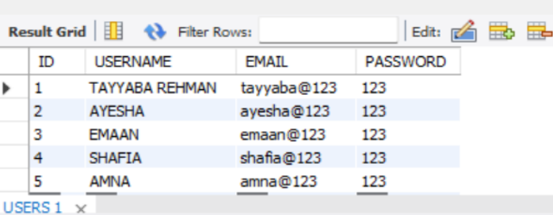

1. **PRODUCTS:**

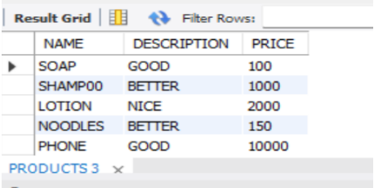

1. **ORDERS:**

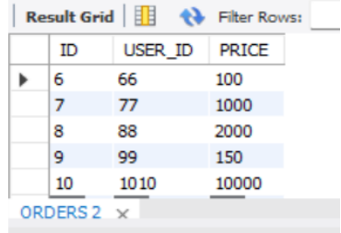

1. **ORDER_ITEMS:**

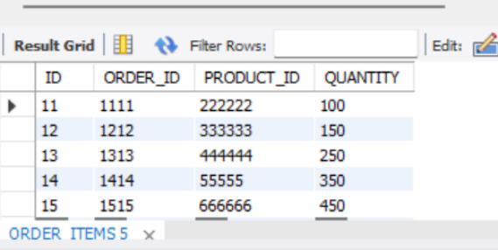

**LAB TASK 2:**

**CODE:**

CREATE DATABASE Library;

USE Library;

CREATE TABLE BOOKS (

BOOK_ID INT PRIMARY KEY,

TITLE VARCHAR(100) NOT NULL,

AUTHOR VARCHAR(100) NOT NULL

);

INSERT INTO BOOKS

(BOOK_ID,TITLE,AUTHOR)

VALUES

(1,"AAB E HAYAT","TAYYABA"),

(2,"PEER E KAMIL","EMAAN"),

(3,"JANNAT K PATAY","AYESHA");

CREATE TABLE MEMBERS (

MEMBER_ID INT PRIMARY KEY,

FIRST_NAME VARCHAR(50) NOT NULL,

LAST_NAME VARCHAR(50)

);

INSERT INTO MEMBERS

(MEMBER_ID,FIRST_NAME,LAST_NAME)

VALUES

(4,"FATIMA","MALIK"),

(5,"IZZA","MARYAM"),

(6,"NOOR","AIMEN");

CREATE TABLE ENROLLEMENTS (

ENROLLEMENT_ID INT PRIMARY KEY,

STUDENT_ID INT NOT NULL,

COURSE_ID INT NOT NULL

);

INSERT INTO ENROLLEMENTS

(ENROLLEMENT_ID,STUDENT_ID,COURSE_ID)

VALUES

(11,111,1111),

(22,222,2222),

(33,333,3333);

CREATE TABLE DEPARTMENTS (

DEPARTMENT_ID INT PRIMARY KEY,

DEPARTMENT_NAME VARCHAR(100)

);

INSERT INTO DEPARTMENTS

(DEPARTMENT_ID,DEPARTMENT_NAME)

VALUES

(11111,"BSCS"),

(22222,"BSSE"),

(33333,"BCA"),

(44444,"DPT");

CREATE TABLE EMPLOYEES (

EMPLOYEE_ID INT PRIMARY KEY,

FIRST_NAME VARCHAR(50) NOT NULL,

LAST_NAME VARCHAR(50)

);

INSERT INTO EMPLOYEES

(EMPLOYEE_ID,FIRST_NAME,LAST_NAME)

VALUES

(56,"AQSA","KHURAM"),

(57,"ASMA","ASMA"),

(58,"DEHER","ZAINAB");

DROP TABLE MEMBERS;

**Q5.** Which SQL Datatype which you used for storing a phone number and why?

Ans. We can use INT and VANCHAR for storing a phone number. INT can be used when a user wants to enter just phone numbers as phone numbers are in the form of integers and he don’t want to use ( -, + ).

e.g.., 03312345

VANCHAR can be used when the user wants to use ( -, +) in the phone number.

e.g.., 0333-56478937, +923467788

**Q10. Delete the table Members from the Library database.**

**Ans.** DROP TABLE MEMBERS;

**OUTPUT:**

1. **BOOKS:**

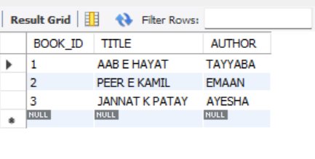

1. **MEMBERS:**

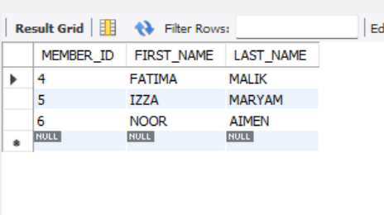

1. **ENROLLEMENTS:**

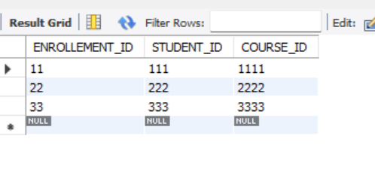

1. **DEPARTMENTS:**

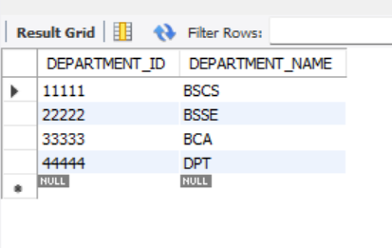

1. **EMPLOYEES:**

